## Customer Requirements Speciﬁcation

**SAG ML Text Recognition CRS ـــــــــــــــــــــــــــــــــــــــــــــــــــــــــــــــــــــــــــــــــــــــــــــــــــــــــــــــــــــــــــــــــــــــــــــــــــــــــــــــــــــــــــــــــــــــــــــــــــــــــــــــــــــــــــــــــــــــــــــــــــــــ**

**Table of Contents**

Document Status 1

Document History 2

Reference Document 2

Project Description 3

Features 3

Key Elements 3

System Context4

CRS Requirements4

# Document Status:

|  |  |  |
| --- | --- | --- |
| **Name** | PO_SAG_CRS_ML_TR | |
| Version | V1.1 | |
| Status | proposed | |
| Author | AES | |
| Date | [8-13-2022] | |
| Team approval | AES | Approved |
| Mentor approval |  |  |
| Final approval |  |  |

# 

# Document History:

|  |  |  |  |
| --- | --- | --- | --- |
| **Version** | **Author** | **Date** | **Change** |
| 1.0 | AA | [8-11-2022] | * Initial Creation * Add CRS Requirements |
| 1.1 | AES | [8-13-2022] | * Edit The Document Title. * Edit the Reference Document version. * Edit the Project Definition, Features , Key Elements and Requirements. |

# Reference Document:

|  |  |  |  |
| --- | --- | --- | --- |
| **Ref.number** | **Doc.Name** | **Version** | **Status** |
| 1 | PO_SAG_CR_ML | V1.2 | Released |

# Project Description:

## Definition:

The Text Recognition aims to help the blind read by extracting and recognizing text from different kinds of images and then converting it to a sound that they can hear.

## Features:

* Text Recognition.

## Key Elements:

* The Text Recognition model shall recognize text including handwritten on other objects (book, paper, sign, etc.).

## **Text Recognition**

## System Context:

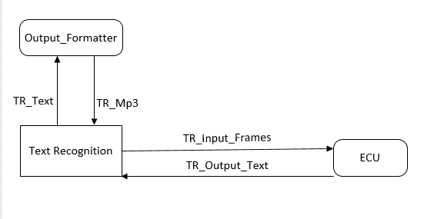



## CRS Requirements:

|  |  |  |  |
| --- | --- | --- | --- |
| **Req_ID** | Req_PO_SAG_CRS_ML_TR_***001***-V1.0 | **Covers** | PO_SAG_CR_ML_004-V1.1 |
| **Description** | The Text Recognition model shall edit the dimensions of each image. | | |

|  |  |  |  |
| --- | --- | --- | --- |
| **Req_ID** | Req_PO_SAG_CRS_ML_TR_***002***-V1.0 | **Covers** | PO_SAG_CR_ML_004-V1.1 |
| **Description** | The Text Recognition model shall encode each character of a word into a numerical value . | | |

|  |  |  |  |
| --- | --- | --- | --- |
| **Req_ID** | Req_PO_SAG_CRS_ML_TR_***003***-V1.0 | **Covers** | PO_SAG_CR_ML_004-V1.1 |
| **Description** | The Text Recognition model shall have 2 architectures of CNN and Bidirectional-LSTM. | | |

|  |  |  |  |
| --- | --- | --- | --- |
| **Req_ID** | Req_PO_SAG_CRS_ML_TR_***004***-V1.0 | **Covers** | PO_SAG_CR_ML_004-V1.1 |
| **Description** | The CNN architecture shall process each image to extract the features of each character. | | |

|  |  |  |  |
| --- | --- | --- | --- |
| **Req_ID** | Req_PO_SAG_CRS_ML_TR_***005***-V1.0 | **Covers** | PO_SAG_CR_ML_004-V1.1 |
| **Description** | The Bidirectional-LSTM architecture shall take the features from the CNN architecture which outputs SoftMax probabilities over the vocabulary. | | |

|  |  |  |  |
| --- | --- | --- | --- |
| **Req_ID** | Req_PO_SAG_CRS_ML_TR_***006***-V1.0 | **Covers** | PO_SAG_CR_ML_004-V1.1 |
| **Description** | The CTC decoder shall take these probabilities from different time steps to finally get the raw text from images. | | |

|  |  |  |  |
| --- | --- | --- | --- |
| **Req_ID** | Req_PO_SAG_CRS_ML_TR_***007***-V1.0 | **Covers** | PO_SAG_CR_ML_004-V1.1 |
| **Description** | Output formatter shall format the text output to Output Formatter. | | |

|  |  |  |  |
| --- | --- | --- | --- |
| **Req_ID** | Req_PO_SAG_CRS_ML_TR_***008***-V1.0 | **Covers** | PO_SAG_CR_ML_004-V1.1 |
| **Description** | The Text Recognition model shall return the output to the ECU. | | |